 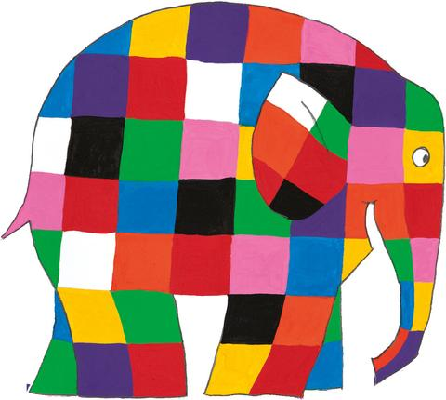Create Your Own Elmer

Here is an example:

Directions:

1. Color in each smaller square on the larger square in a patchwork design.
2. Cut along the solid lines.
3. Fold along the dotted lines.
4. Glue the extra square you cut off to create an ear for Elmer. If you colored both large squares in, you can glue or tape them together to create a two sided elephant.

