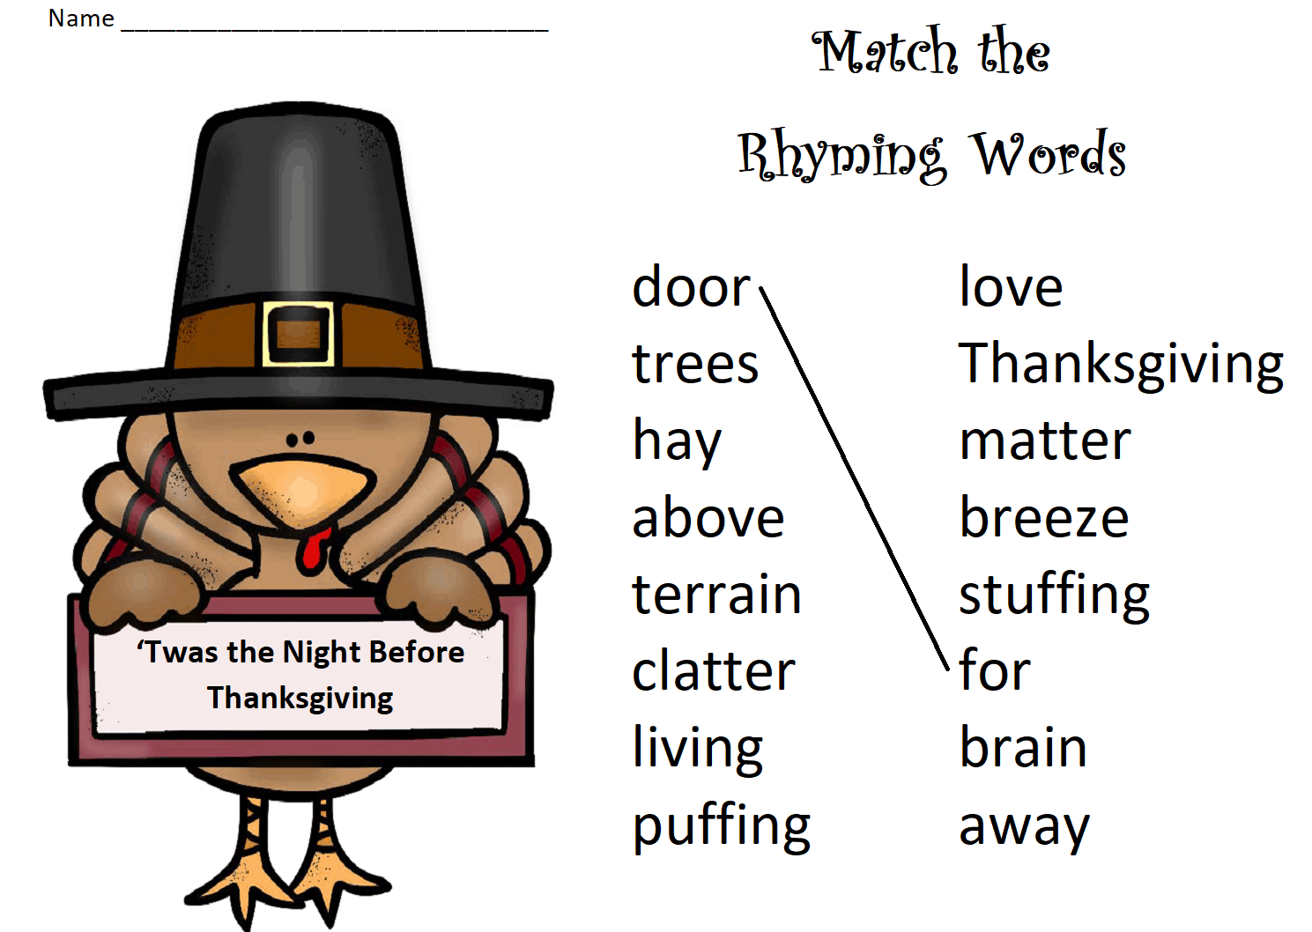

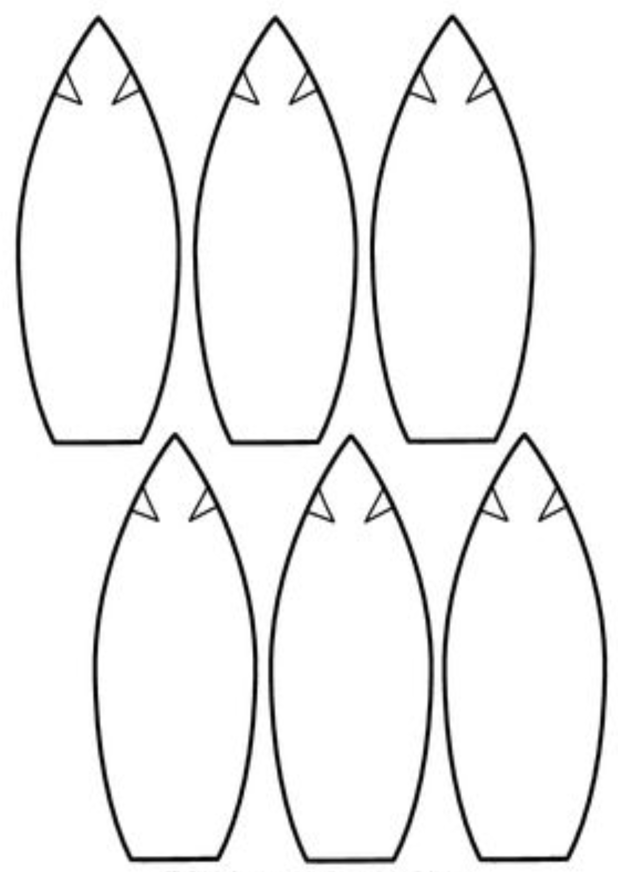

**Make Your Own Turkey**

1. Color and cut out the turkey’s head and feet.
2. Write what you are grateful for on each of the feathers or leave some blank to share with your family.
3. Color the feathers and cut them out.
4. Glue the pieces to a toilet paper roll or empty tissue box.